Social Network Email Analysis in Python Proposal

**Background**

Social network analysis is the mapping and measuring of relationships between people, groups and other connected entities. It characterises people as nodes and relationships/interactions as edges between them.

**Task**

Create network analysis focusing on our relationship with Scor employees. This will allow Stuart to have a measurable index to report on and feedback to Jean-Paul and Laurent over time. Initially we can start with the actuarial team’s emails. The data we will extract will be (“to”, ”from”, ”cc”, ”date”). We will not be extracting the content or subject of the email.

We will import data from each member’s inbox and sent mail. This data is grouped using Python and analysed to view our communications to and from Scor.

**Further Opportunities**

* View relationships over time. For example, Channel employees building relationships with Scor. We will look to trial this on the actuarial team by analysing networks over time between us and Scor. We are hoping to see an increase in communication between us and Scor over the last 2 years.
* Underwriters to work together to bring business to Scor/Channel. Underwriters could view the relationships between Scor/channel to external parties. This means that instead of creating a new relationship, a relationship could be built using a trusted employee to start on a positive footing.
* 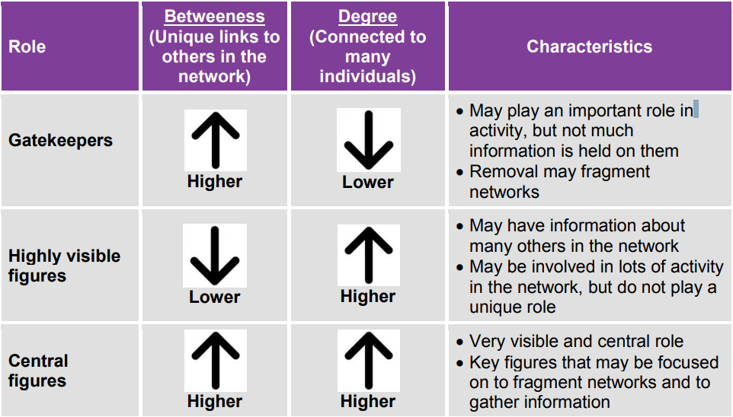Allows analysis of key people within the organisation, summarised into ‘Gatekeepers’, ‘Highly visible figures’, and ‘Central figures’. See below: